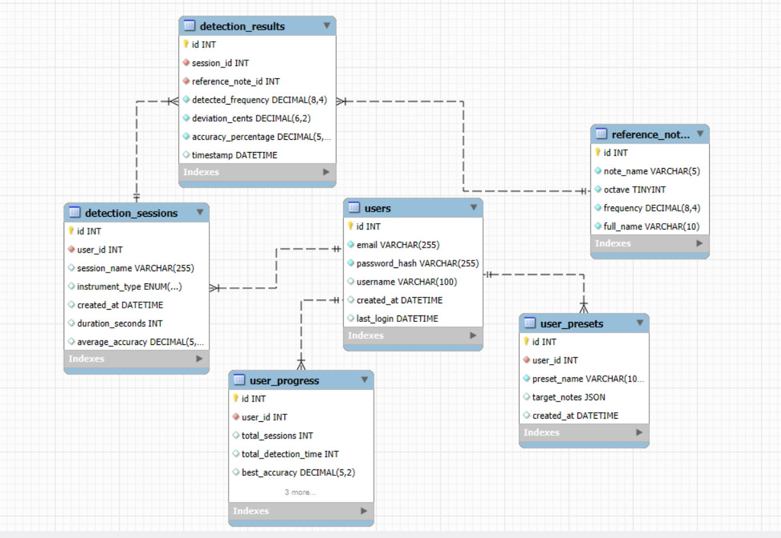
-- Создание базы данных
CREATE DATABASE IF NOT EXISTS pitch_detector CHARACTER SET utf8mb4 COLLATE utf8mb4_unicode_ci;
USE tonal_detector;

-- Таблица пользователей
CREATE TABLE users (
id INT PRIMARY KEY AUTO_INCREMENT,
email VARCHAR(255) UNIQUE NOT NULL,
password_hash VARCHAR(255) NOT NULL,
username VARCHAR(100),
created_at DATETIME DEFAULT CURRENT_TIMESTAMP,
last_login DATETIME NULL,
INDEX idx_email (email),
INDEX idx_created_at (created_at)
);

-- Таблица эталонных нот (основная справочная)
CREATE TABLE reference_notes (
id INT PRIMARY KEY AUTO_INCREMENT,
note_name VARCHAR(5) NOT NULL, -- C, C#, D, D#, E, F, F#, G, G#, A, A#, B
octave TINYINT NOT NULL, -- 3, 4, 5
frequency DECIMAL(8,4) NOT NULL, -- эталонная частота в Hz
full_name VARCHAR(10) UNIQUE NOT NULL, -- C4, C#4, D4 и т.д.
INDEX idx_frequency (frequency),
INDEX idx_full_name (full_name),
INDEX idx_note_octave (note_name, octave)
);

-- Таблица сессий детектирования
CREATE TABLE detection_sessions (
id INT PRIMARY KEY AUTO_INCREMENT,
user_id INT NOT NULL,
session_name VARCHAR(255),
instrument_type ENUM('vocal', 'synth') DEFAULT 'vocal',
created_at DATETIME DEFAULT CURRENT_TIMESTAMP,
duration_seconds INT DEFAULT 0,
average_accuracy DECIMAL(5,2) DEFAULT 0.00,
FOREIGN KEY (user_id) REFERENCES users(id) ON DELETE CASCADE,
INDEX idx_user_id (user_id),
INDEX idx_created_at (created_at),
INDEX idx_instrument_type (instrument_type)
);

-- Таблица результатов детектирования (основные данные)
CREATE TABLE detection_results (
id INT PRIMARY KEY AUTO_INCREMENT,
session_id INT NOT NULL,
reference_note_id INT NOT NULL,
detected_frequency DECIMAL(8,4) NOT NULL,
deviation_cents DECIMAL(6,2) NOT NULL, -- отклонение в центах
accuracy_percentage DECIMAL(5,2) NOT NULL, -- точность в %
timestamp DATETIME DEFAULT CURRENT_TIMESTAMP,
FOREIGN KEY (session_id) REFERENCES detection_sessions(id) ON DELETE CASCADE,
FOREIGN KEY (reference_note_id) REFERENCES reference_notes(id),
INDEX idx_session_id (session_id),
INDEX idx_timestamp (timestamp),
INDEX idx_accuracy (accuracy_percentage)
);

-- Таблица пользовательских пресетов
CREATE TABLE user_presets (
id INT PRIMARY KEY AUTO_INCREMENT,
user_id INT NOT NULL,
preset_name VARCHAR(100) NOT NULL,
target_notes JSON, -- JSON массив нот для тренировки
created_at DATETIME DEFAULT CURRENT_TIMESTAMP,
FOREIGN KEY (user_id) REFERENCES users(id) ON DELETE CASCADE,
INDEX idx_user_id (user_id),
INDEX idx_preset_name (preset_name)
);

-- Таблица прогресса пользователя
CREATE TABLE user_progress (
id INT PRIMARY KEY AUTO_INCREMENT,
user_id INT NOT NULL UNIQUE,
total_sessions INT DEFAULT 0,
total_detection_time INT DEFAULT 0, -- в секундах
best_accuracy DECIMAL(5,2) DEFAULT 0.00,
average_accuracy DECIMAL(5,2) DEFAULT 0.00,
favorite_note VARCHAR(10),
last_practice_date DATETIME NULL,
FOREIGN KEY (user_id) REFERENCES users(id) ON DELETE CASCADE,
INDEX idx_best_accuracy (best_accuracy),
INDEX idx_last_practice (last_practice_date)
);

-- Заполняем эталонные ноты для 3 октав (вокальный диапазон + синтезатор)
INSERT INTO reference_notes (note_name, octave, frequency, full_name) VALUES
-- Октава 3
('C', 3, 130.8100, 'C3'),
('C#', 3, 138.5900, 'C#3'),
('D', 3, 146.8300, 'D3'),
('D#', 3, 155.5600, 'D#3'),
('E', 3, 164.8100, 'E3'),
('F', 3, 174.6100, 'F3'),
('F#', 3, 185.0000, 'F#3'),
('G', 3, 196.0000, 'G3'),
('G#', 3, 207.6500, 'G#3'),
('A', 3, 220.0000, 'A3'),
('A#', 3, 233.0800, 'A#3'),
('B', 3, 246.9400, 'B3'),

-- Октава 4 (основная)
('C', 4, 261.6300, 'C4'),
('C#', 4, 277.1800, 'C#4'),
('D', 4, 293.6600, 'D4'),
('D#', 4, 311.1300, 'D#4'),
('E', 4, 329.6300, 'E4'),
('F', 4, 349.2300, 'F4'),
('F#', 4, 369.9900, 'F#4'),
('G', 4, 392.0000, 'G4'),
('G#', 4, 415.3000, 'G#4'),
('A', 4, 440.0000, 'A4'),
('A#', 4, 466.1600, 'A#4'),
('B', 4, 493.8800, 'B4'),

-- Октава 5
('C', 5, 523.2500, 'C5'),
('C#', 5, 554.3700, 'C#5'),
('D', 5, 587.3300, 'D5'),
('D#', 5, 622.2500, 'D#5'),
('E', 5, 659.2500, 'E5'),
('F', 5, 698.4600, 'F5'),
('F#', 5, 739.9900, 'F#5'),
('G', 5, 783.9900, 'G5'),
('G#', 5, 830.6100, 'G#5'),
('A', 5, 880.0000, 'A5'),
('A#', 5, 932.3300, 'A#5'),
('B', 5, 987.7700, 'B5');

-- Тестовые пользователи
INSERT INTO users (email, password_hash, username, last_login) VALUES
('test@example.com', '123456', 'TestUser', NOW()),
('vocalist@mail.com', '123456', 'VocalMaster', NOW()),
('synth@mail.com', '123456', 'SynthPlayer', NOW());

-- Тестовые сессии
INSERT INTO detection_sessions (user_id, session_name, instrument_type, duration_seconds, average_accuracy) VALUES
(1, 'Утренняя тренировка', 'vocal', 300, 85.50),
(1, 'Работа над интонацией', 'vocal', 450, 78.20),
(2, 'Синтезатор практика', 'synth', 600, 92.10);

-- Тестовые результаты детектирования
INSERT INTO detection_results (session_id, reference_note_id, detected_frequency, deviation_cents, accuracy_percentage) VALUES
-- Сессия 1
(1, 14, 440.5000, 1.96, 98.00), -- A4, почти идеально
(1, 16, 330.2000, -8.42, 91.60), -- E4, немного низко
(1, 19, 392.8000, 3.51, 96.50), -- G4, немного высоко

-- Сессия 2
(2, 13, 262.1000, 3.24, 96.80), -- C4
(2, 17, 350.5000, 6.52, 93.50), -- F4
(2, 20, 416.8000, 6.48, 93.50), -- G#4

-- Сессия 3
(3, 15, 277.0000, -1.12, 98.90), -- C#4
(3, 18, 311.0000, -0.75, 99.30), -- D#4
(3, 21, 466.0000, -0.69, 99.30); -- A#4

-- Пользовательские пресеты
INSERT INTO user_presets (user_id, preset_name, target_notes) VALUES
(1, 'Базовые ноты', '["C4", "D4", "E4", "F4", "G4", "A4", "B4"]'),
(1, 'Хроматическая гамма', '["C4", "C#4", "D4", "D#4", "E4", "F4", "F#4", "G4", "G#4", "A4", "A#4", "B4"]'),
(2, 'Аккорды', '["C4", "E4", "G4", "C5"]');

-- Прогресс пользователей
INSERT INTO user_progress (user_id, total_sessions, total_detection_time, best_accuracy, average_accuracy, favorite_note, last_practice_date) VALUES
(1, 2, 750, 98.00, 81.90, 'A4', NOW()),
(2, 1, 600, 99.30, 92.10, 'D#4', NOW()),
(3, 0, 0, 0.00, 0.00, NULL, NULL);

Select * from reference_notes;
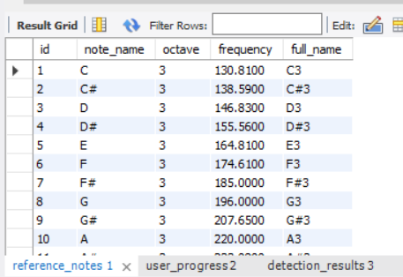

Select * from user_progress;
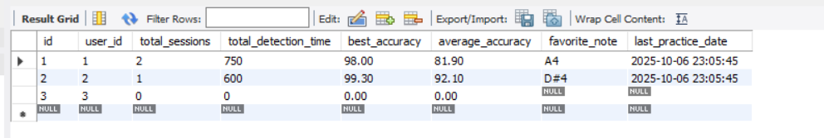

Select * from detection_results;

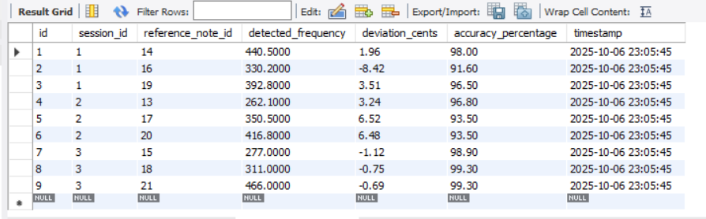
Select * from users;
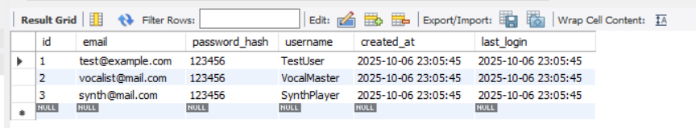

select * from detection_sessions;
